**Chicago Crime Analysis**

**Objective Questions**

1. **Crime Type Analysis:** Assess the frequency of each crime type to identify the most prevalent crimes occurring in the area.

**Answer.**

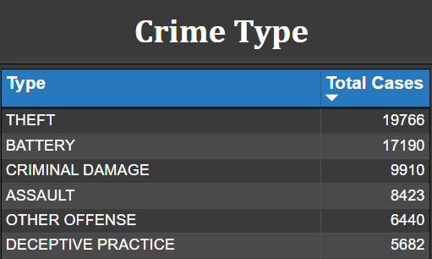

1. **Arrest Rate Evaluation:** Analyze the percentage of reported incidents that have resulted in an arrest to gauge law enforcement effectiveness.

**Answer.** Upon analyzing the dataset, the percentage of reported incidents resulting in an arrest is determined to be 12%

1. **District Crime Distribution Assessment:** Calculate the number of crimes in each district to understand how crime is distributed across the city and identify high-crime areas.

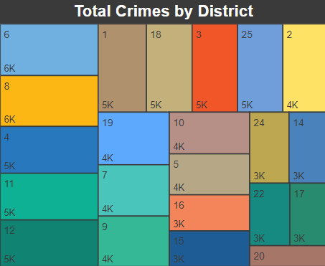

**Answer.** In my analysis, I calculated the total number of crimes in each district to understand the distribution of crime across the city. By examining the data, I identified that Districts 6, 8, 4, 11, and 12 have the highest number of reported crimes indicating areas with higher crime rates.

1. **Domestic Crime Proportion Analysis:** Analyze the ratio of domestic-related crimes to other types of crimes to understand the prevalence of domestic incidents.

**Answer.** In my analysis, I found that domestic-related crimes account for **20.02 %** of all reported incidents. This indicates a notable proportion of domestic incidents within the dataset.

1. Is there any “**Location Description**” where the number of crimes is higher than expected? Come up with a table or visualization in which one can judge the frequency of crimes at each Location Description type.

**Answer.** To identify locations with higher than expected crime rates, I analyzed the frequency of crimes by location description. The table below summarizes the total number of crimes for each location type.

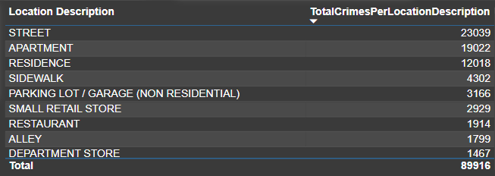

From the analysis, it is evident that certain locations, such as streets and residences, have significantly higher crime rates compared to others. These high frequencies suggest that these locations are hotspots for criminal activities.

1. What is the average time between reporting and solving a case as per the data?

**Answer.** The average time between reporting and solving a case, as calculated from the provided dataset, is 9 days. This was determined using the following **DAX** formula:

Average Time Difference Between Solving Case = **AVERAGEX(crimes_data_2022, crimes_data_2022[Updated On] - crimes_data_2022[Date])**

This formula calculates the average difference in days between the date a crime was reported and the date the case was solved.

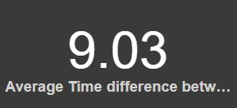

1. In order to reward the patrol officers, find the patrol area where the crimes reported were under control.

**Answer.** To reward the patrol officers, I identified the patrol areas (beats) with the lowest reported crime rates.

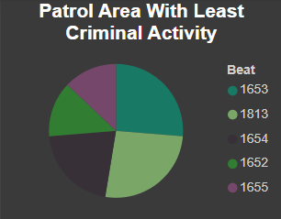

These beats have demonstrated effective crime control and are candidates for officer rewards.

**Subjective Question**

1. Is there any year-wise change in crime rates? If not, what could be the mistake in that operation?

**Answer.** Since the data is only available for 2022, year-wise changes in crime rates couldn't be analyzed. The primary mistake lies in the lack of historical data spanning multiple years.

To address this, consider collecting data from previous years for a more comprehensive analysis.

1. How can we reduce the no. of crimes, and which types of crime should we focus on to achieve improvement in the overall number of crimes?

**Answer.** To reduce overall crime, focus on tackling the top five crime types: **Theft, Battery, Criminal Damage, Assault, and Other Offense**.



Implement targeted strategies such as increased police patrols, community engagement programs, and addressing underlying social issues to deter these types of crimes and make neighborhoods safer.

1. Which localities experience higher crime rates, and what measures can we ensure to reduce these numbers?

**Answer.** Based on the analysis, the following districts have the highest crime rates:

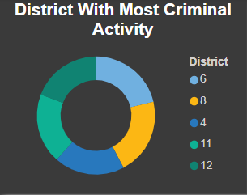

**Measures to Reduce Crime:**

1. **Increase Police Patrols:** More frequent patrols to deter crime.

**2. Community Engagement:** Encourage neighborhood watch programs.

**3. Better Lighting and Surveillance:** Install more streetlights and cameras.

**4. Social Programs:** Support at-risk youth and crime victims.

**5. Regular Crime Analysis:** Monitor trends and allocate resources accordingly.

1. Can you suggest wards where security improvements should be made to reduce crime?

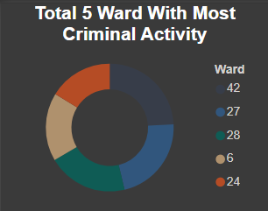

**Answer.** In the wards with the most criminal activity (**Wards** **42**, **27**, **28**, **6**, and **24**), consider security enhancements like increased police patrols, improved street lighting, installation of surveillance cameras, targeted crime prevention programs, and community policing initiatives to address underlying issues and foster a safer environment.

1. **Crime Rate Trend Analysis:** Monitor changes in crime rates over time to detect any discernible patterns or trends.

**Answer.** To monitor changes in crime rates over time within the year 2022, I analyzed the monthly crime data.

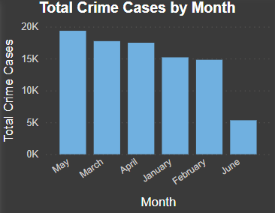

**Trends Observed:**

1. The crime rate was relatively stable from January to February.

2. The highest number of crimes occurred in May.

3. A significant drop in crime rates was observed in June.

1. As per the previous reports, most of domestic crimes do not result in arrest due to public hesitation and family pressure, is this trend also visible in our data?

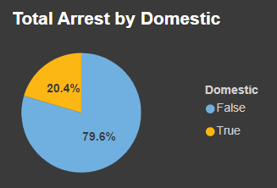

**Answer**. In my analysis, I observed that 20% of domestic crimes resulted in arrest.

While this may indicate a relatively higher arrest rate compared to previous reports citing public hesitation and family pressure, further investigation is needed to determine if similar trends exist in our dataset.

Factors such as changes in reporting practices, law enforcement strategies, and societal attitudes towards domestic crimes could influence arrest rates and warrant closer examination for accurate comparison.

1. Could you generate a visual representation that emphasizes the frequently occurring terms within the **"Description"** column?

**Answer.** To visualize the most common terms in the "Description" column, a **Treemap** visualization was created in Power BI.

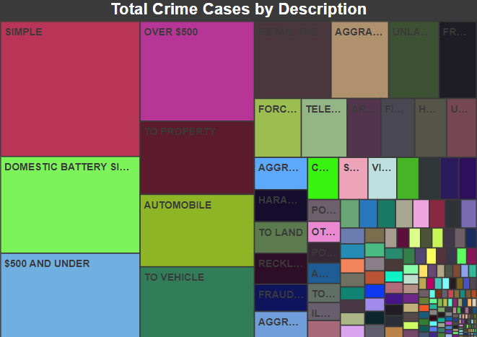

This visualization highlights the terms that frequently appear in crime descriptions. Larger blocks in the Treemap indicate higher frequency, providing a clear overview of the predominant crime types.

1. Are there any particular regions as per the data where the number of domestic crimes reported is very high?

**Answer.**

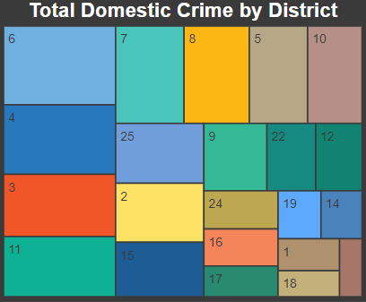

Certain districts had significantly higher numbers of reported domestic crimes. For example, District **6**, District **4**, District **3**, District **11**, and District **7** were notable for their higher domestic crime counts.

1. Is the solving time of cases also dependent upon the type and locality of crime?

**Answer.** Dependency of Solving Time on Crime Type and Locality

The analysis indicates that solving times vary by crime type but are consistent across districts:

**By Crime Type:**

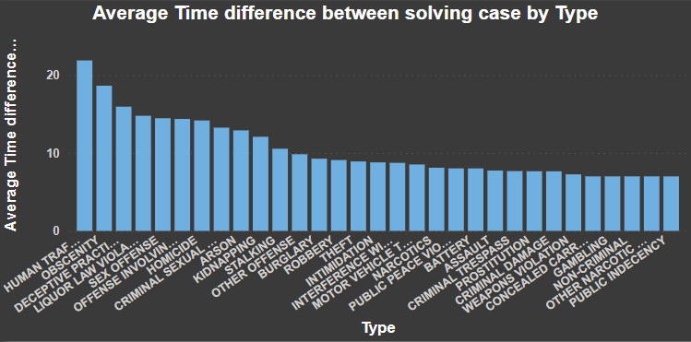

Human Trafficking takes the longest to solve (21 days), followed by Obscenity (18 days).

Public Indecency and nine other types have the shortest solving times (7 days).

**By District:**

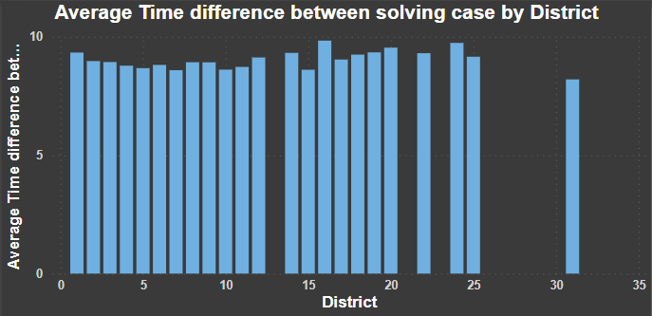

All districts from 1 to 30 have an average solving time of 8 to 9 days, similar to the overall average of 9 days.